**Jenkins-04**

**1) Setup jenkins CICD pipeline using freestyle job using Docker containers using below code.**

[**https://github.com/betawins/hiring-app.git**](https://github.com/betawins/hiring-app.git)

***Stages:***

***1) Git Clone***

***2) Sonarqube Integration***

***3) Maven Compilation***

***4) Nexus Artifactory***

***5) Slack Notification***

***6) Deploy On tomcat***

1. **Git Clone**

Jenkins Freestyle Job Configuration

**Create Job**

* Go to Jenkins → New Item → select **Freestyle Project** → name it hiring-app

**Git Clone**

* In job configuration → Source Code Management → select **Git**.
* Repository URL:

<https://github.com/betawins/hiring-app.git>

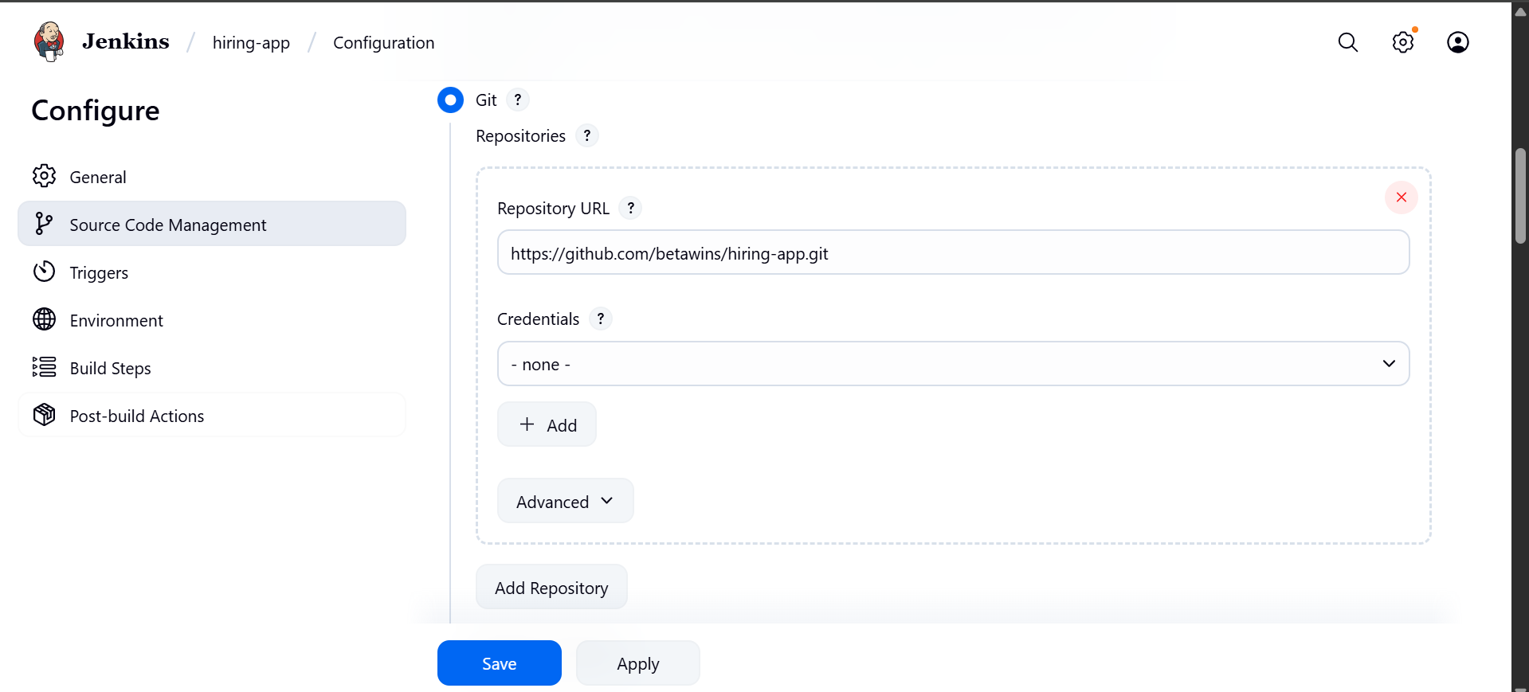

**2.** **SonarQube Integration --using Docker**

**Create a sonarqube-ec2 take t2.large and installed docker and pull image of sonarqube.**

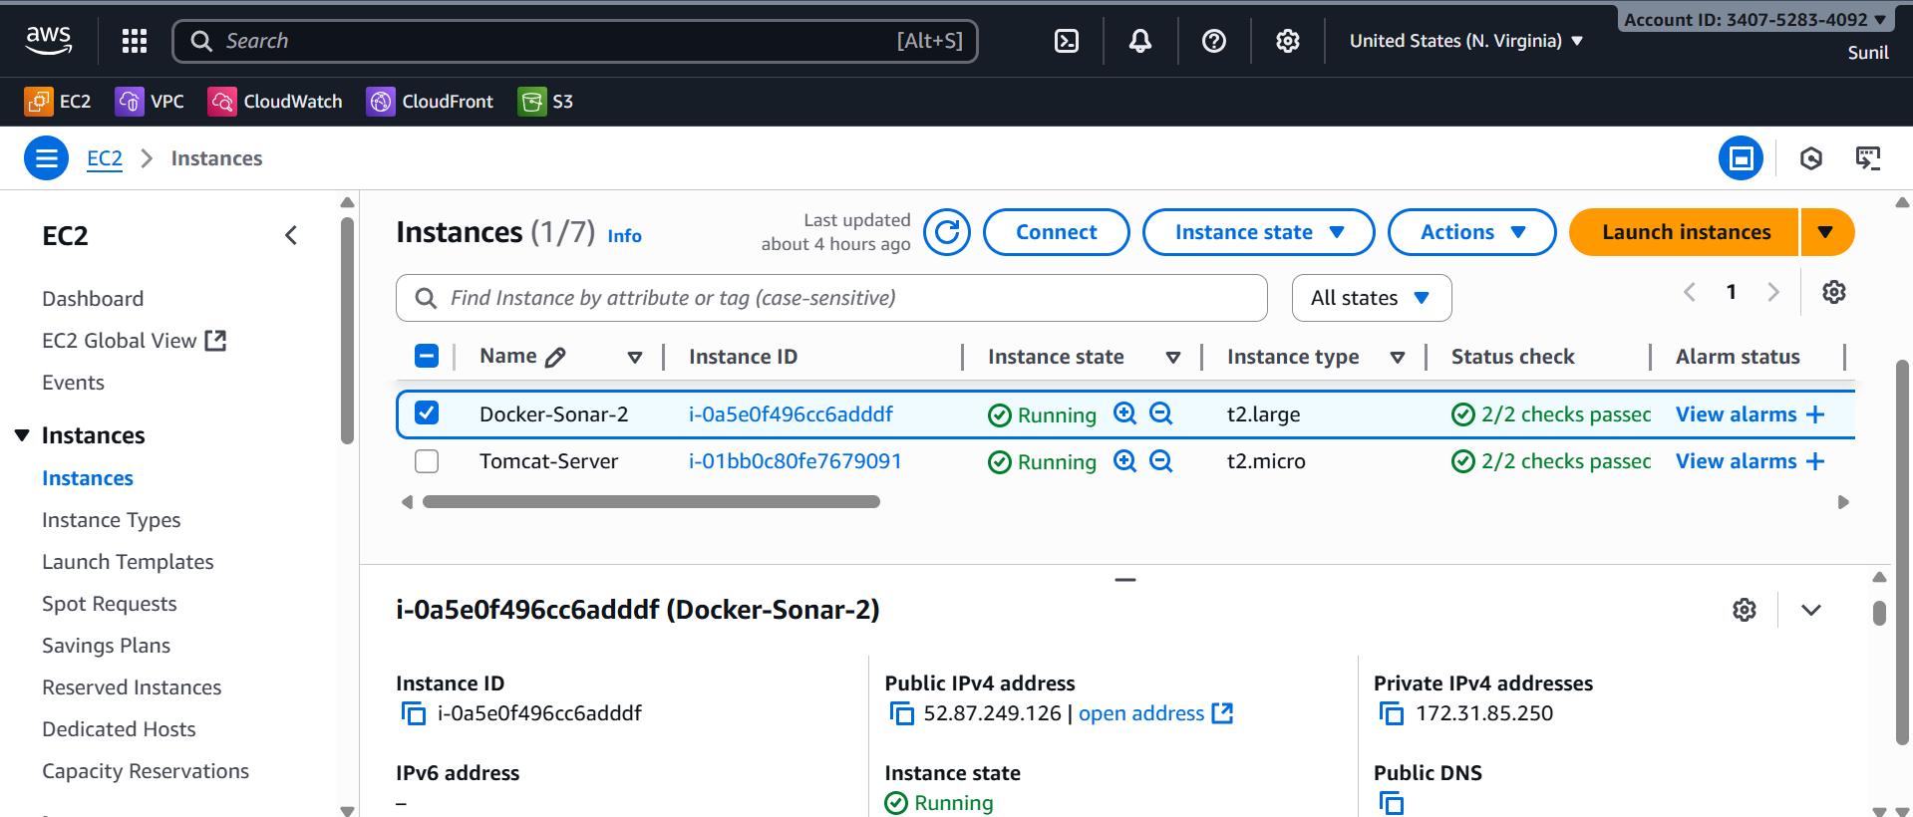

**yum -y install docker**

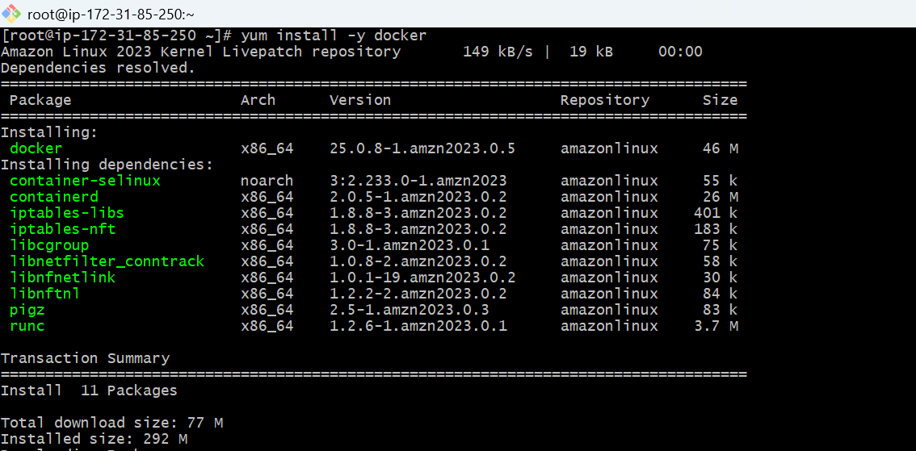

**systemctl start docker**

**docker pull sonarqube**

**docker run -d --name sonarqube -p 9001:9000 sonarqube:lts**

**Docker ps**

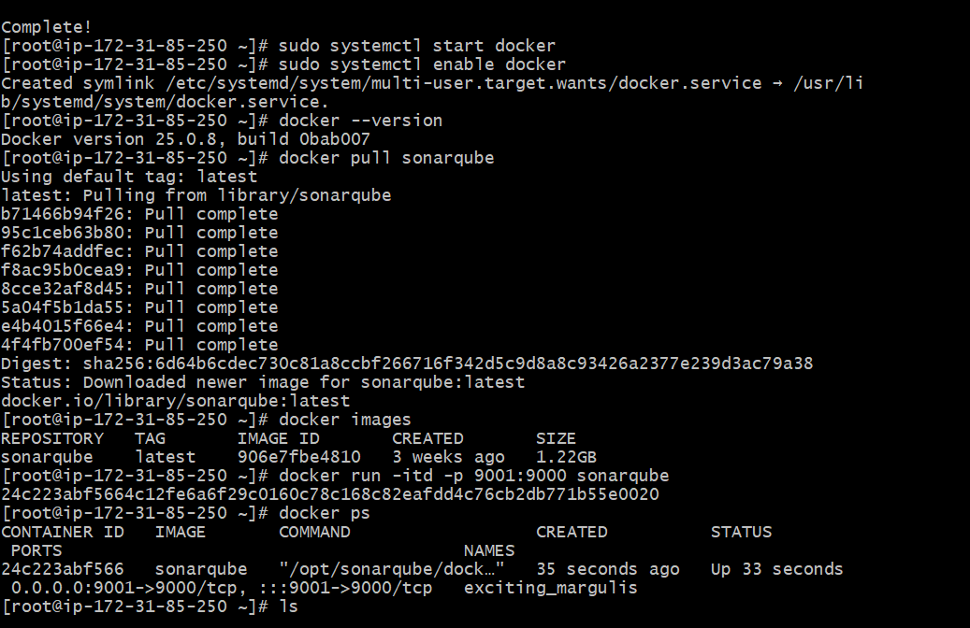

Install sonrQube Scanner Plugin in Jenkins

In Jenkins Dashboard:

* Go to **Manage Jenkins → Plugins → Available Plugins**.
* Search & install:
* **SonarQube Scanner for Jenkins**

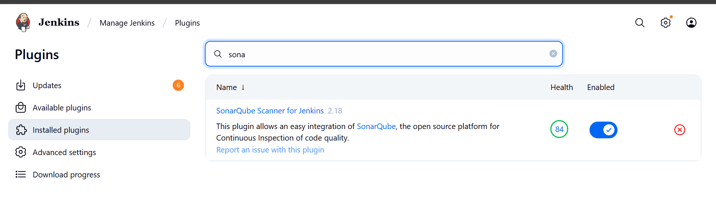

In Jenkins Master edit the sonar properties

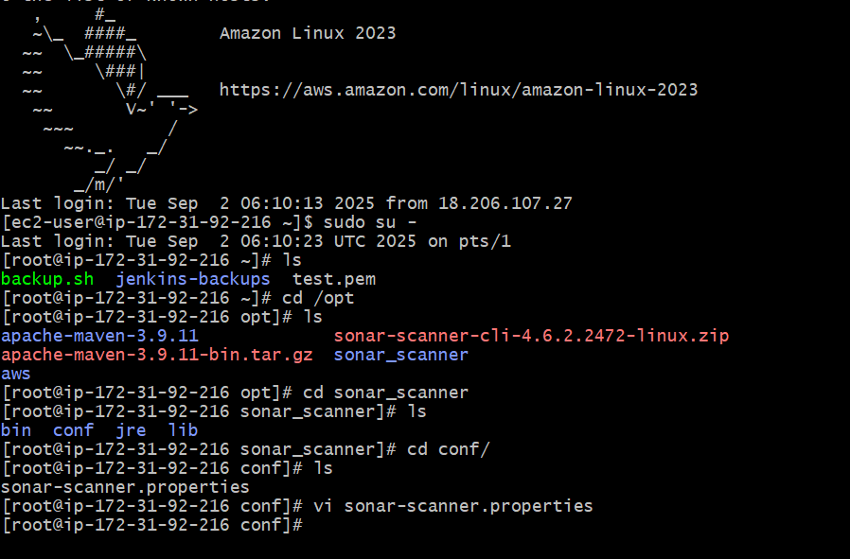

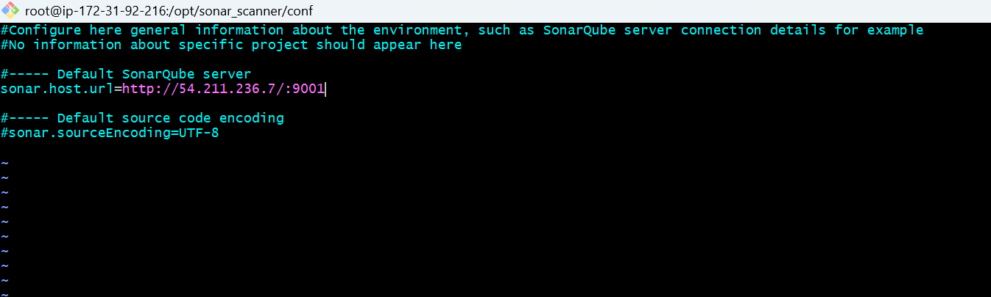

: Configure SonarQube Server

* Go to **Manage Jenkins → System**
* Scroll to **SonarQube servers** → Click **Add SonarQube**.

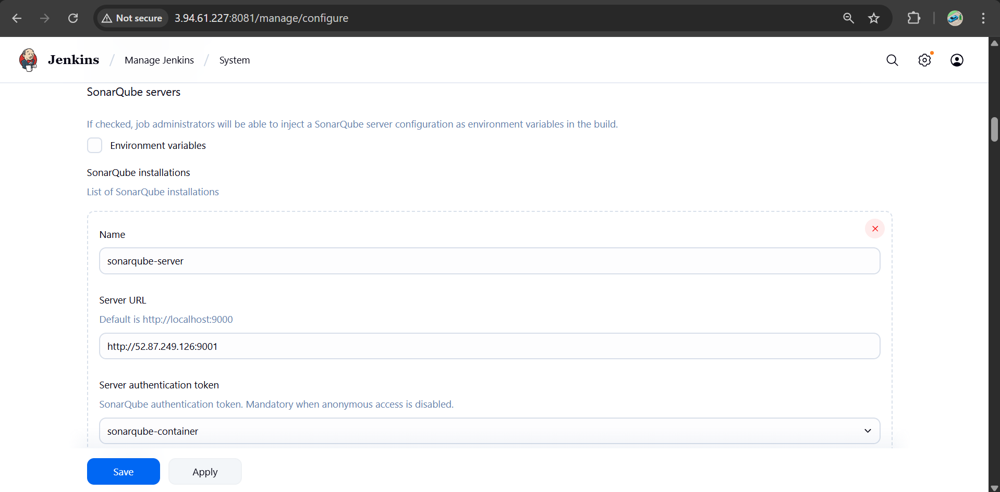

http://sonarqube-ip:9001

**Server authentication token**:

* Login to SonarQube UI → My Account → Security → Generate Token.
* Add it as a **Secret Text Credential** in Jenkins.

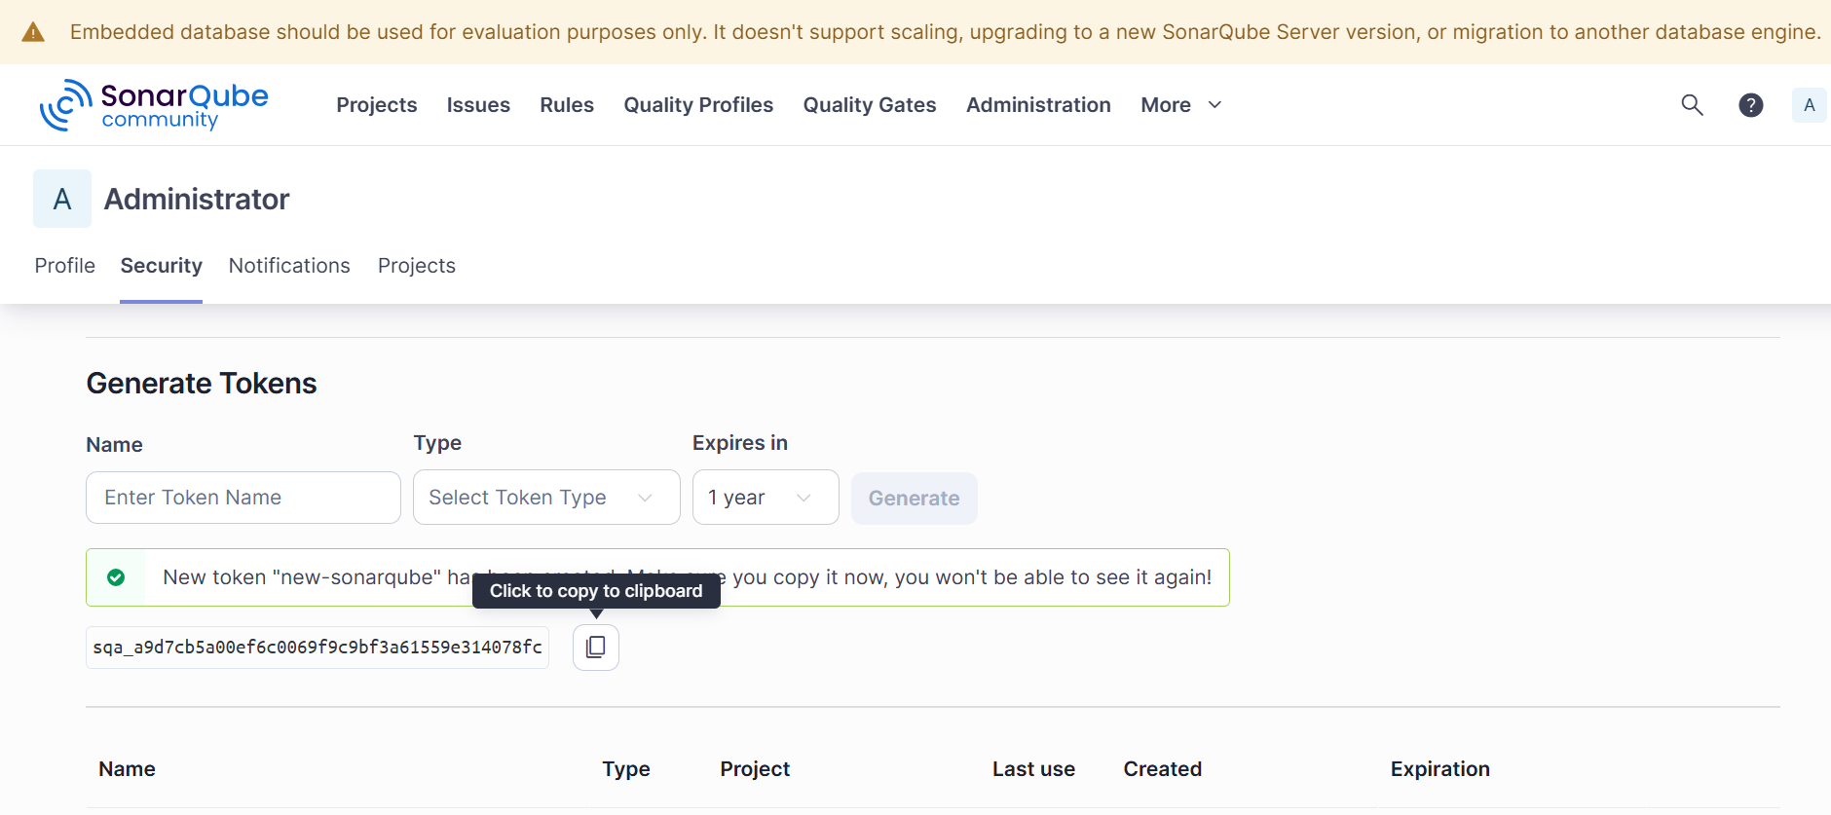

### Configure SonarQube Scanner

* Go to **Manage Jenkins → Tools**
* Under **SonarQube Scanner installations** → Add → Name it sonar­_scanner.

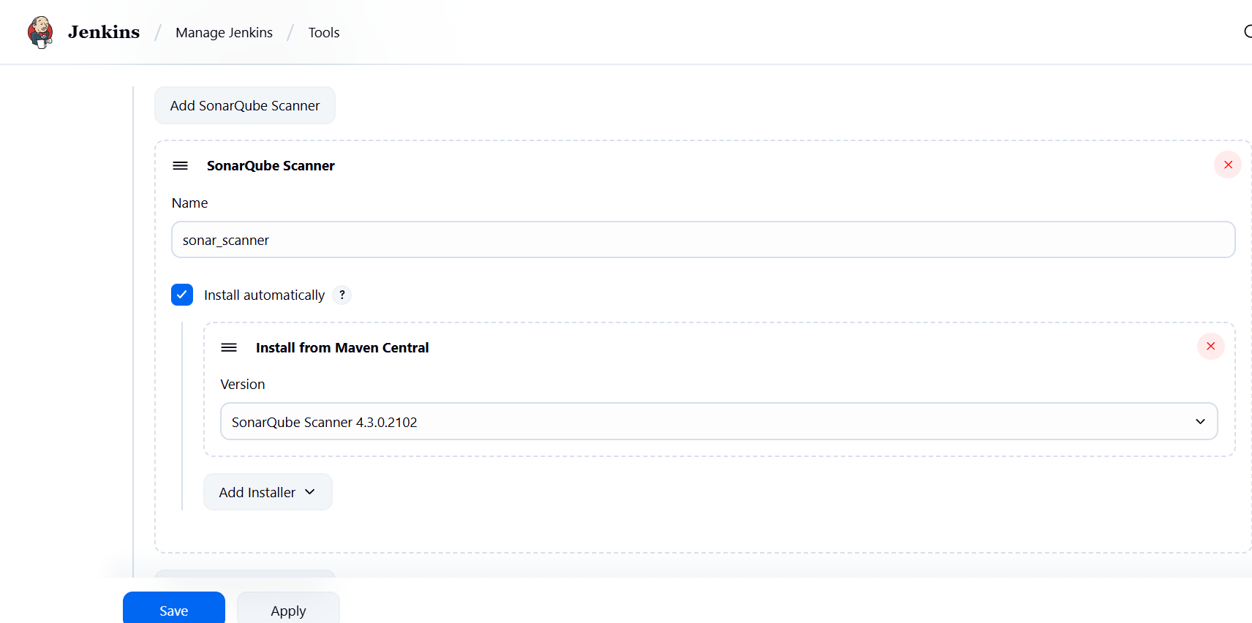

### ****SonarQube Integration****

* In Jenkins: **Manage Jenkins → Configure System** → set SonarQube server details.
* In build step: Add **Execute SonarQube Scanner** with properties:

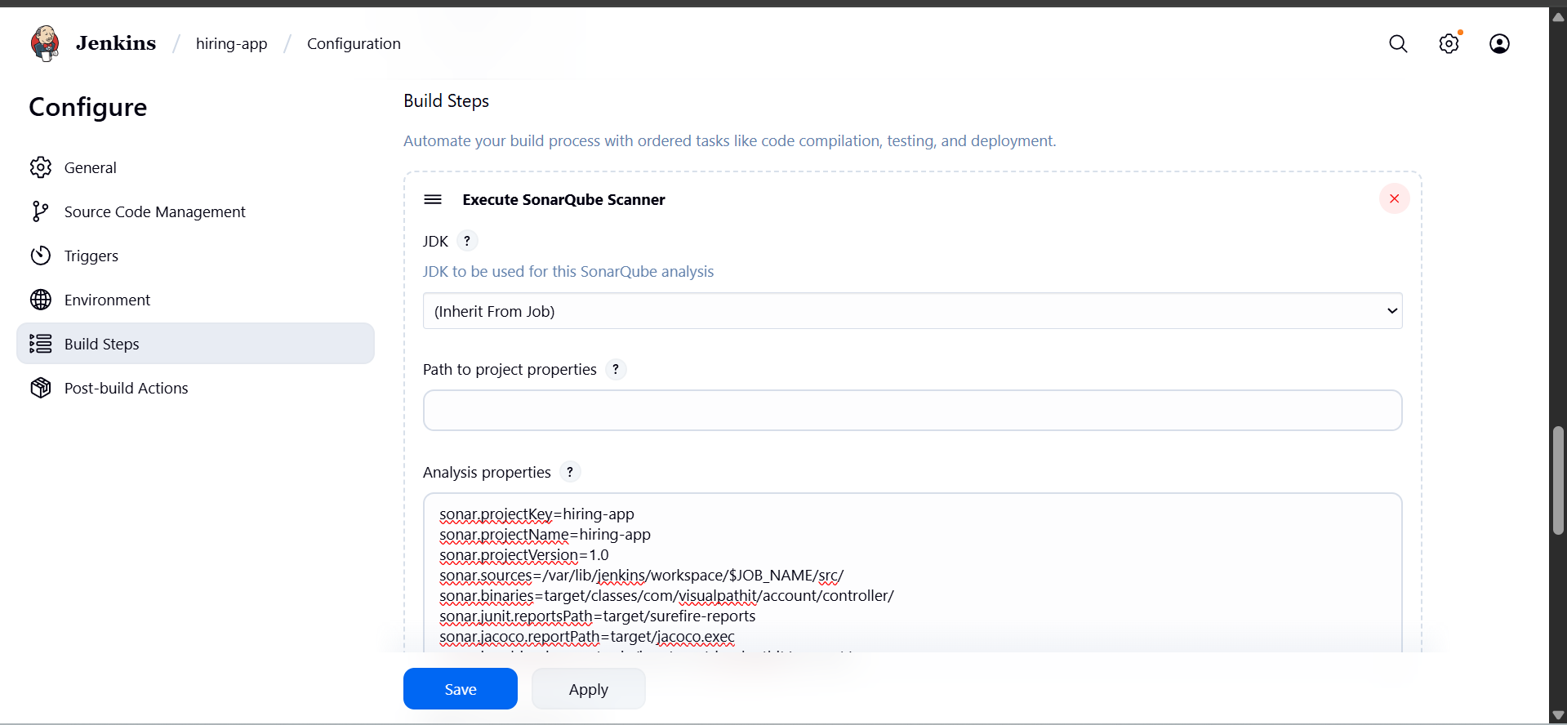

* This will analyze code quality and send results to SonarQube container.
* Now start build

**And check the sonarqube for code quality**

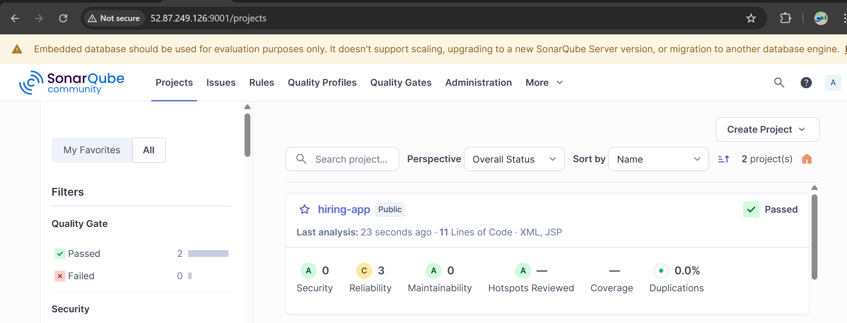

**3. Maven Compilation**

Install & Configure Maven in Jenkins

download apche maven in jenkins master

cd /opt

wget <https://dlcdn.apache.org/maven/maven-3/3.9.11/binaries/apache-maven-3.9.11-bin.tar.gz>

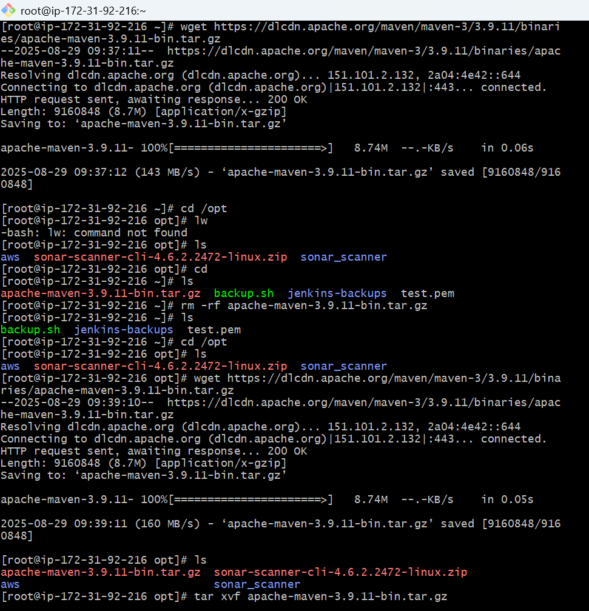

**tar -xvf apache-maven-3.9.11-bin.tar.gz**

**cd apache-maven-3.9.11/bin**

**Store global variable in script to access maven –version**

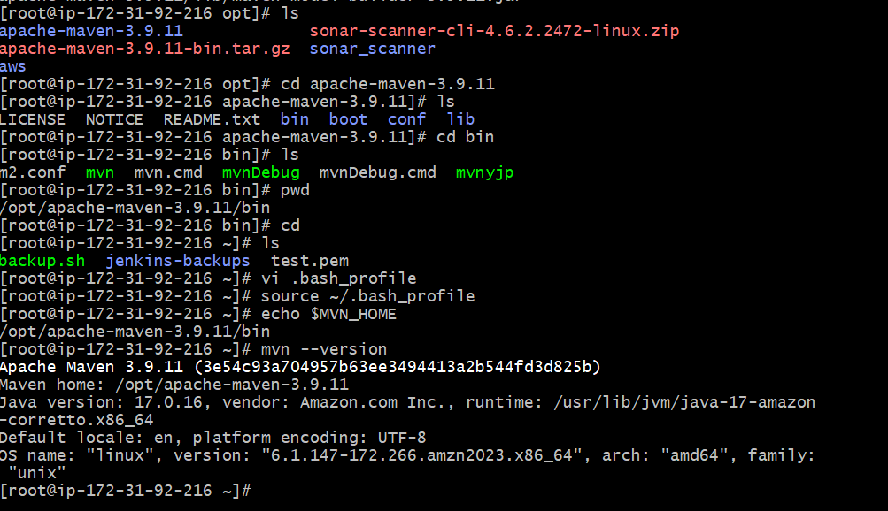

**In jenkins server** edit the file and some details → **vi .bash_profile**

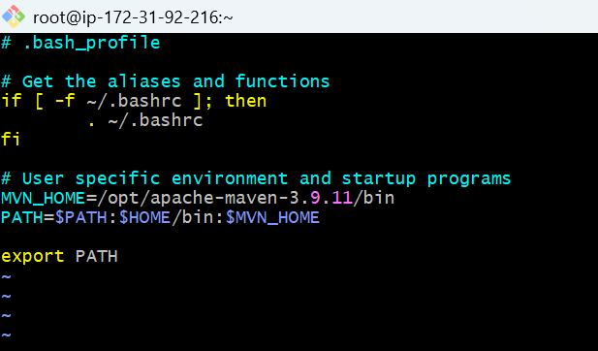

Now go to manage jenkins --> tools --> maven --> /opt/apache-maven-3.9.11

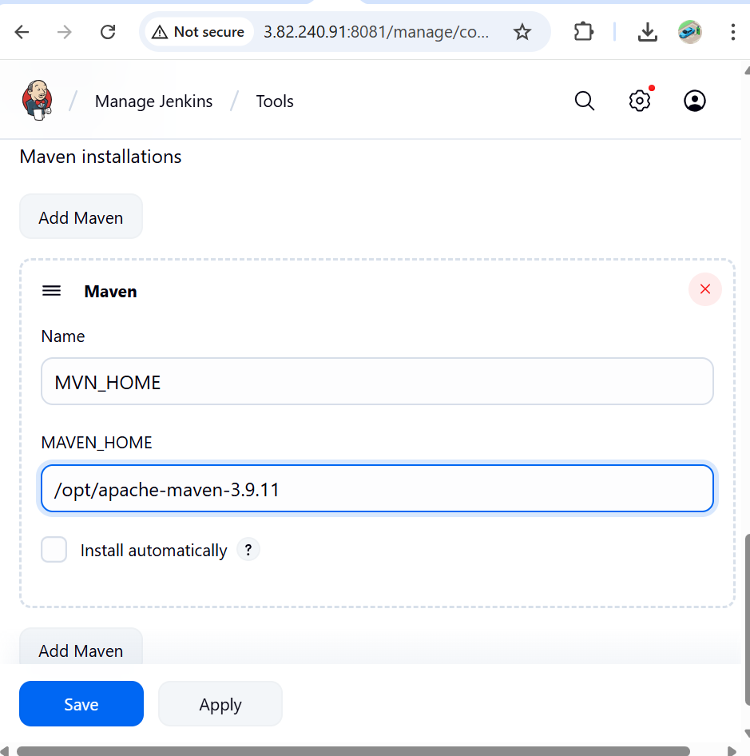

Add build step → **Invoke top-level Maven targets**.

Goals: clean

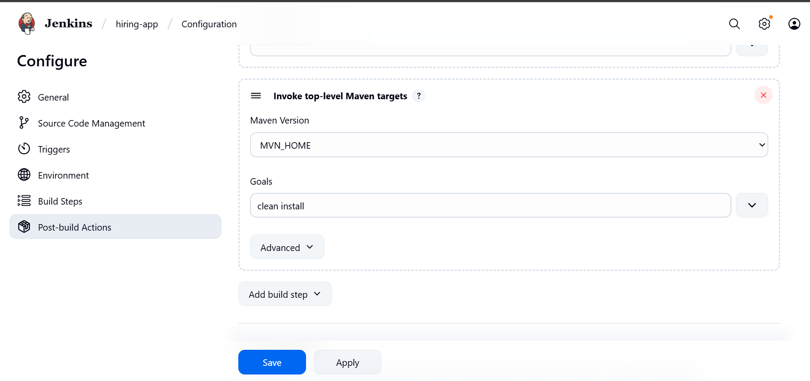

Now run the build then git clone done, sonarqube integration done, then maven created a war file.

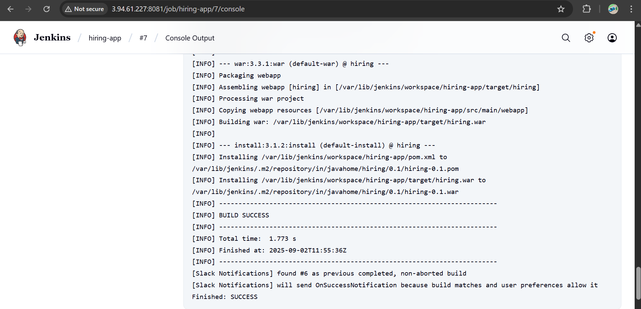

**In jenkins server → cd /var/lib/jenkins/workspace/hiring-app/target**

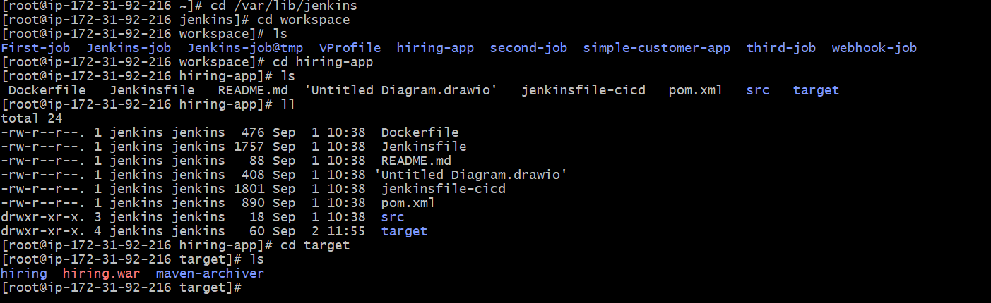

We can check dependencies in jenkins server

cd /var/lib/jenkins/.m2/repository

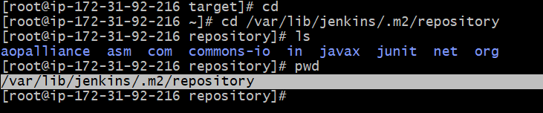

**4. Nexus Artifactory**

1. Now create nexus-ec2 with t2.large
2. Install java → **yum -y install java-1.8\***

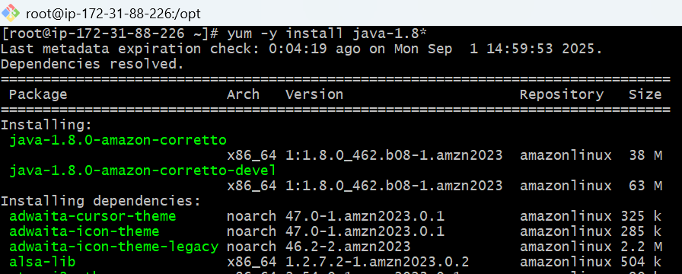

1. And now download nexus

cd /opt

wget <https://sonatype-download.global.ssl.fastly.net/nexus/3/nexus-3.0.2-02-unix.tar.gz>

tar -zxvf nexus-3.0.2-02-unix.tar.gz

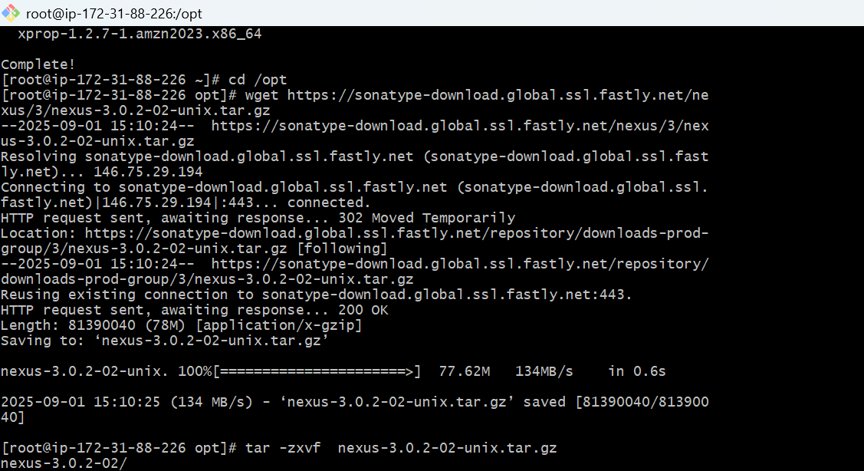

mv /opt/nexus-3.0.2-02 /opt/nexus

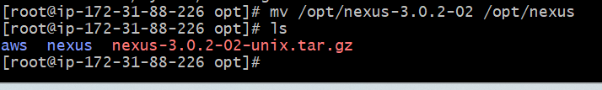

Open /opt/nexus/bin/nexus.rc file,

uncomment run_as_user parameter and set it as following.

vi /opt/nexus/bin/nexus.rc

Remove # and Add → run_as_user="**ec2-user**"

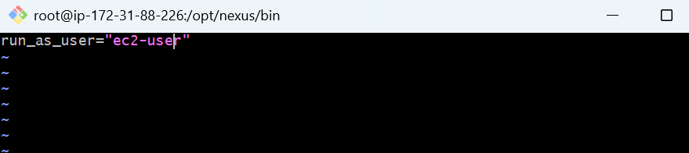

* Now switch to ec2-user give ownership and start and check status.
* Cd /opt
* Give permissions → **sudo** **chown -R ec2-user:ec2-user nexus**

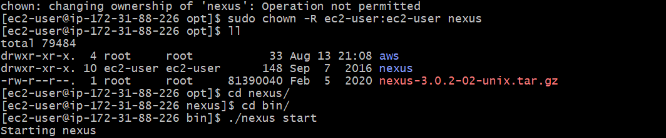

* **Cd /opt/nexus/bin**
* **./nexus start**
* **./nexus status**

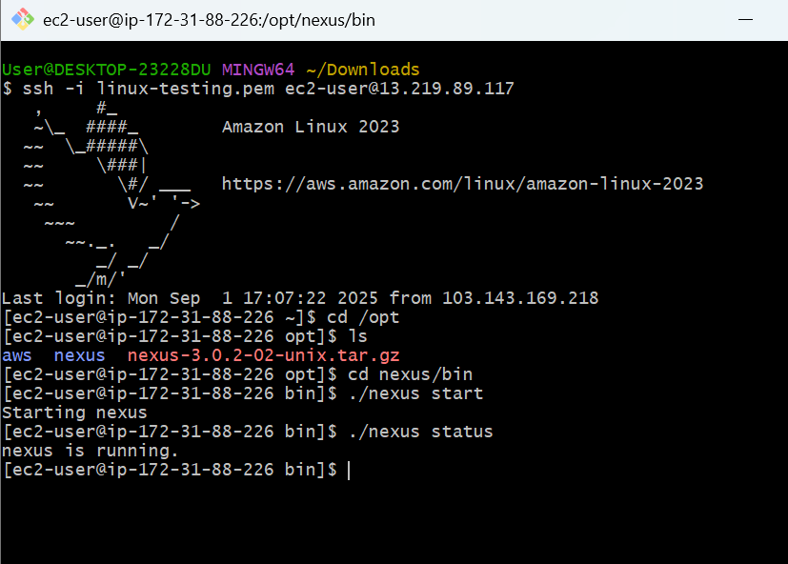

Login nexus server from browser on port 8081

http://<Nexus_server>:8081

Use default credentials to login

username : admin

password : admin123

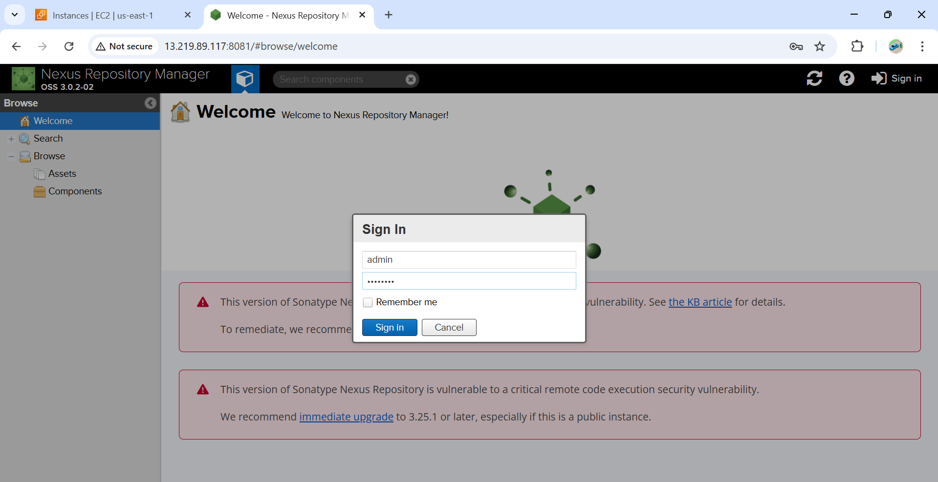

**Integrate jenkins with nexus**

Install Nexus plugin

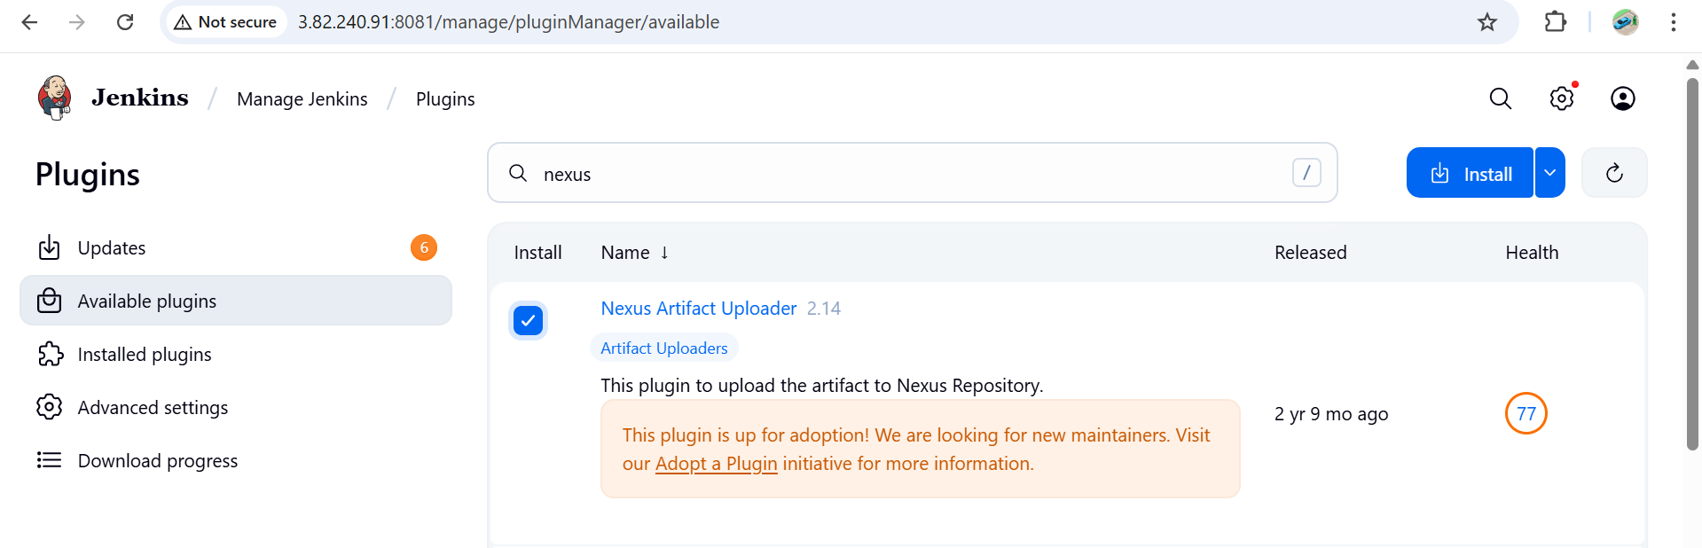

**Now go to your job → configure → build step → nexus**

**In git hub repo in pom.xml file we have some info group id and version, bring and enter here and goto nexus create repository → maven2(host) and take release.**

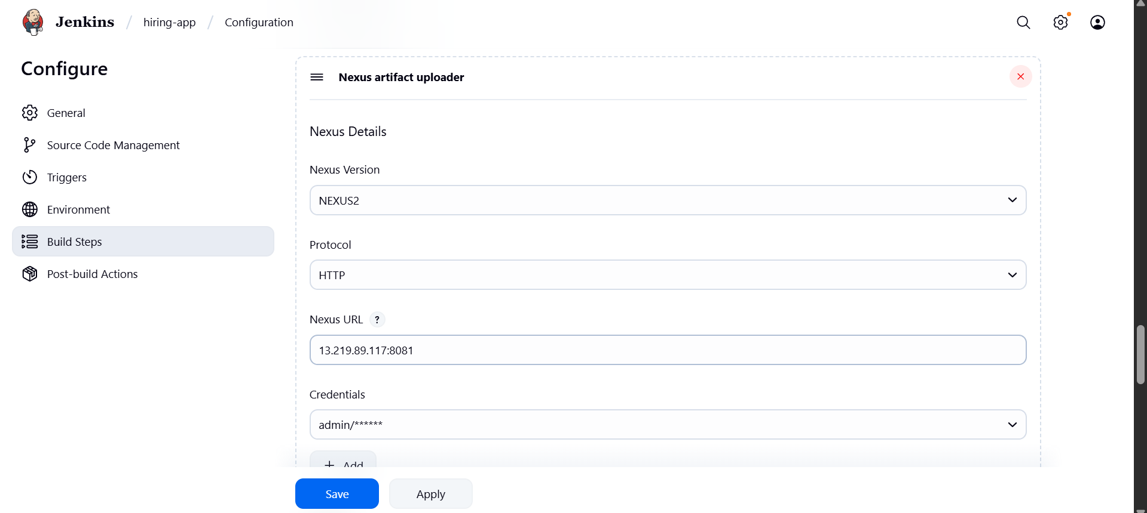

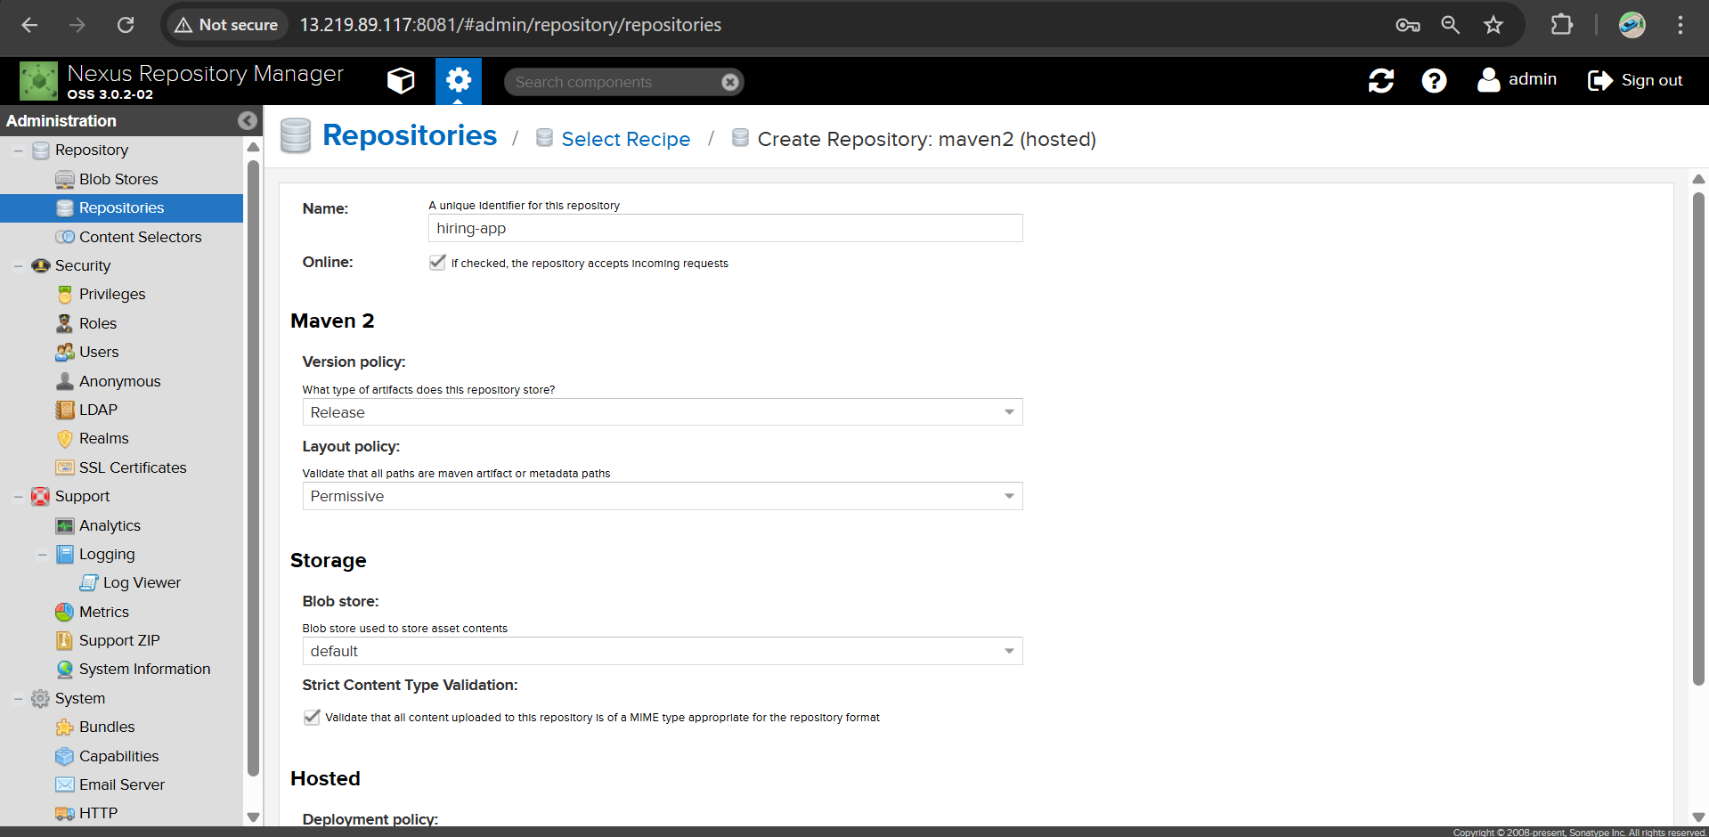

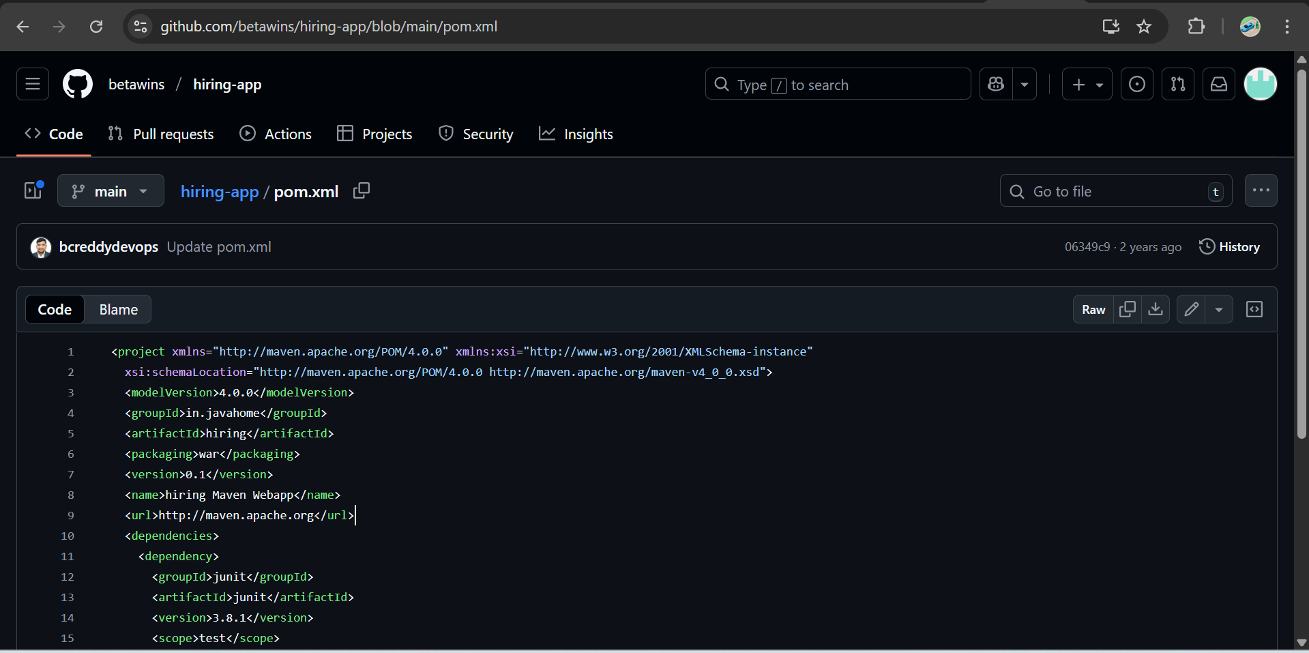

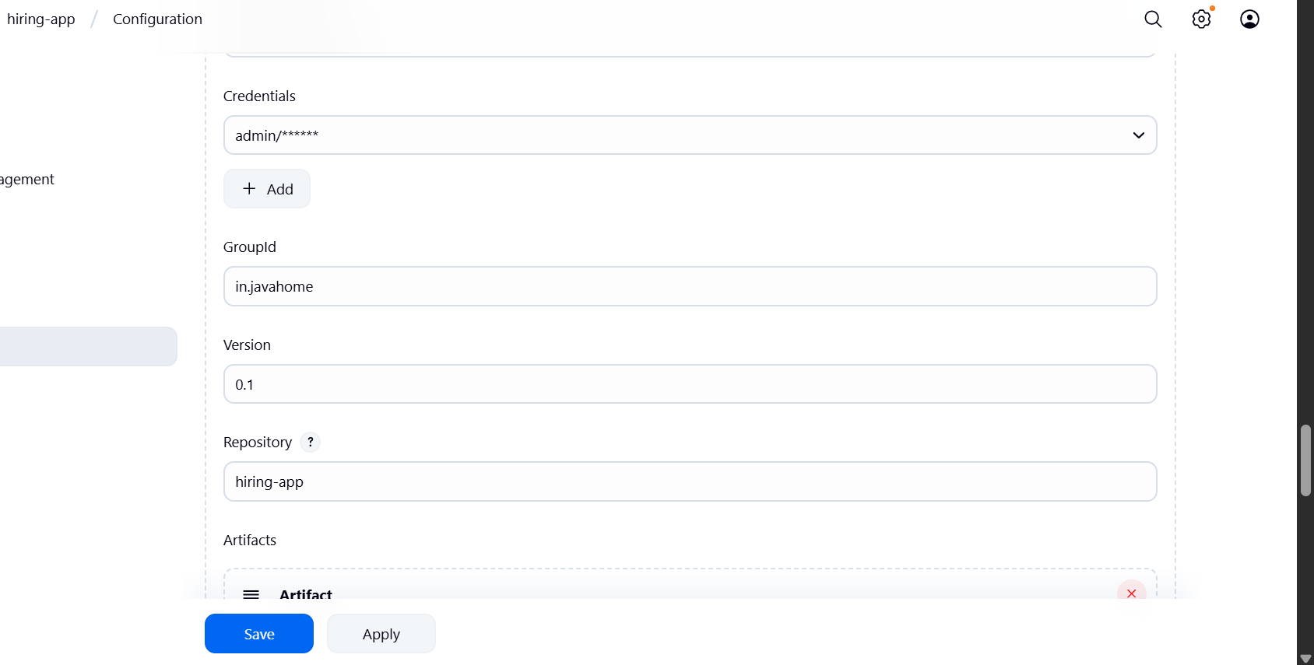

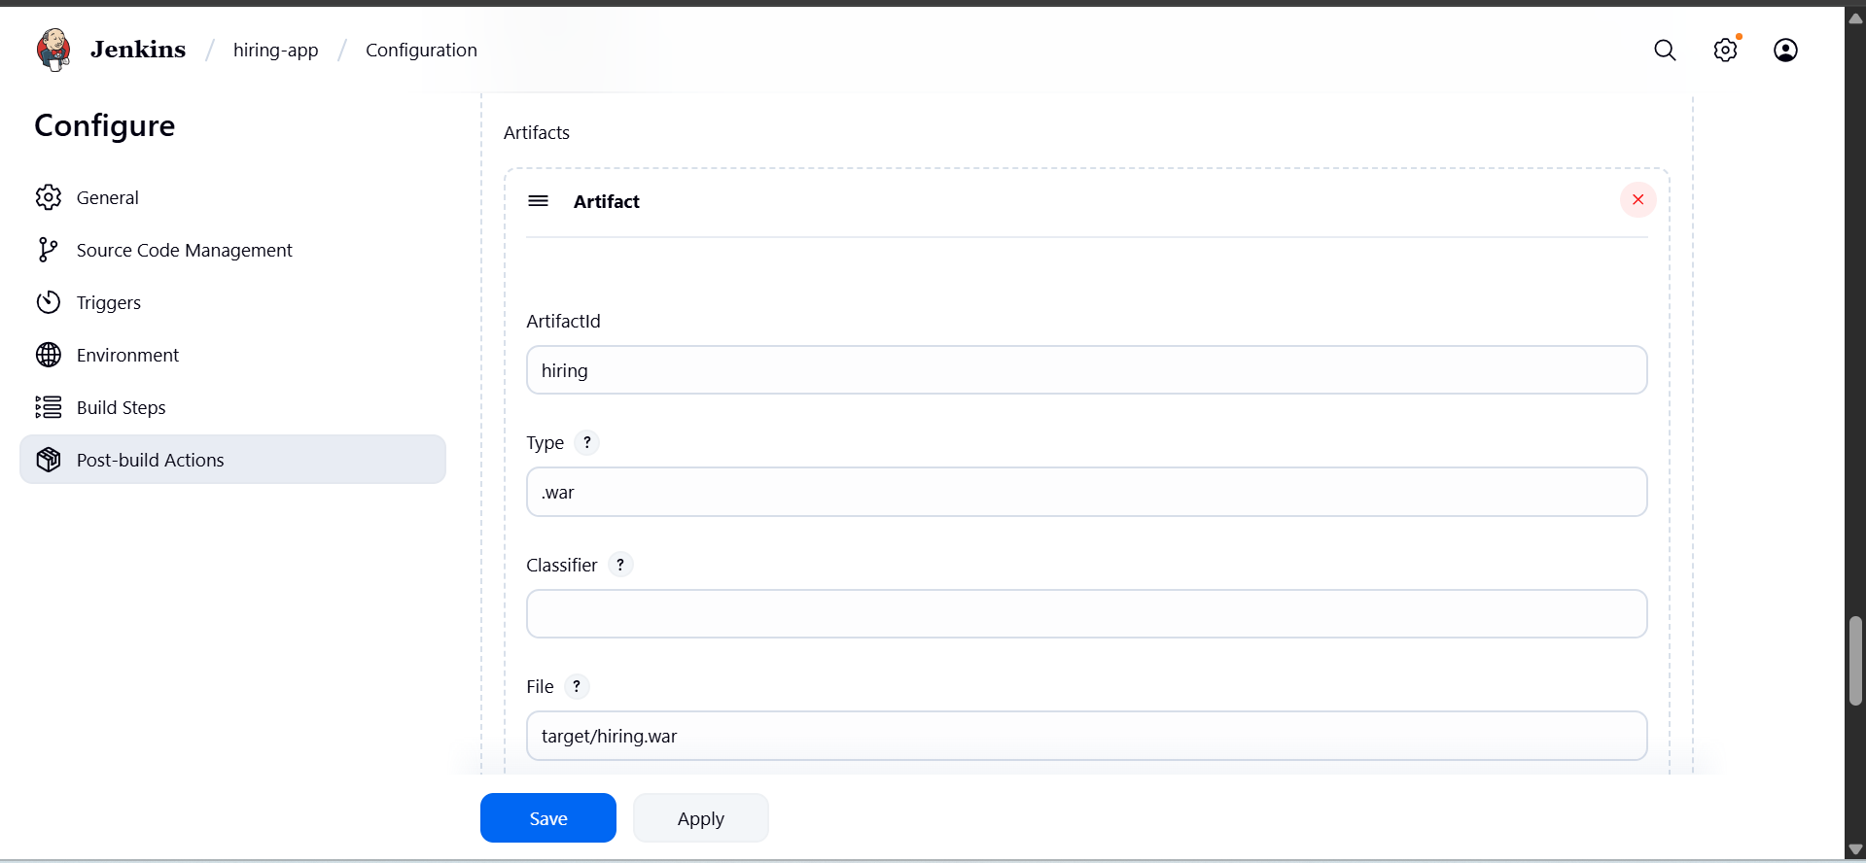

**Now run build**

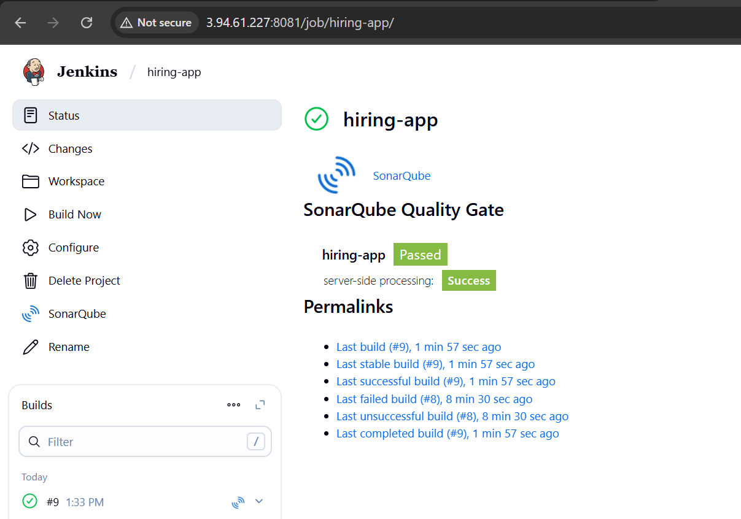

Check Nexus for war file

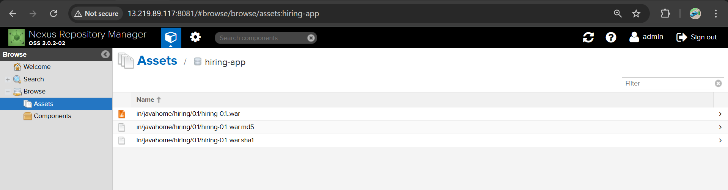

**5) Slack Notification**

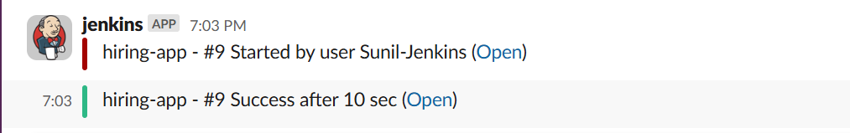

**6) Deploy On tomcat**

**Go to jenkins page Install plugin → deploy to container**

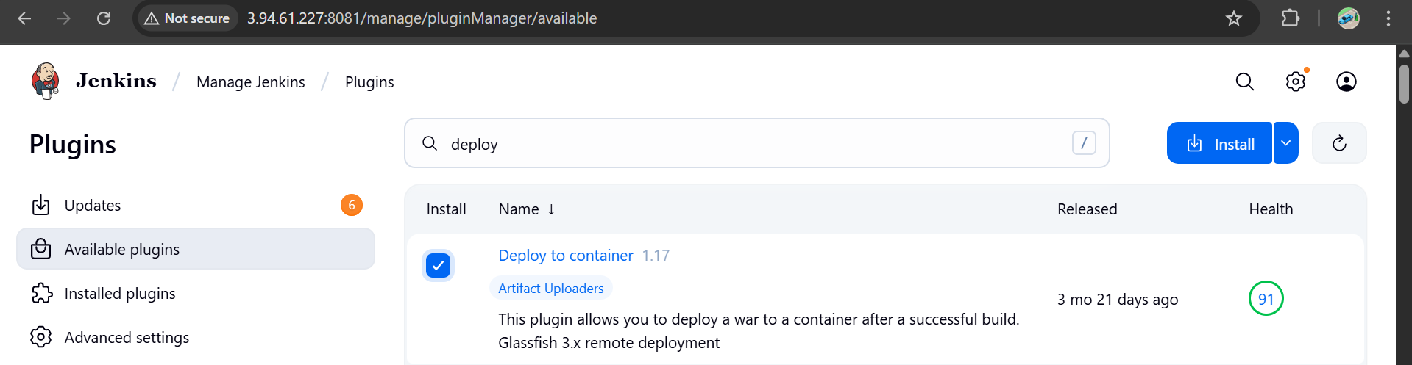

**Now launch an ec2 instance**

**Install java and install tomcat in it**

**And start**

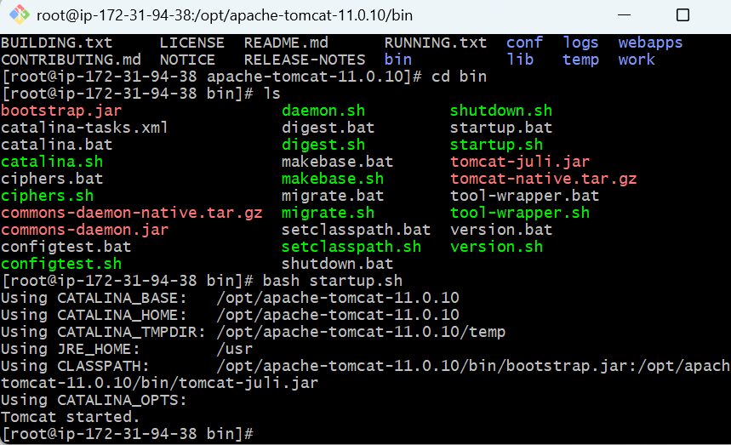

Check on the web with the public ip

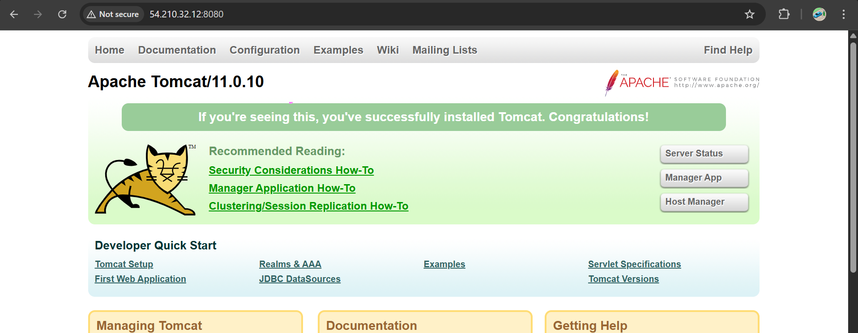

* **Now create user in tomcat.**
* **Take file webapps and edit for uncomment the four files**
* **find / -name context.xml**

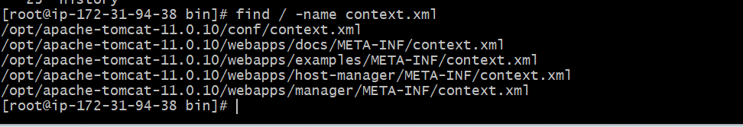

vi /opt/apache-tomcat-11.0.10/webapps/docs/META-INF/context.xml

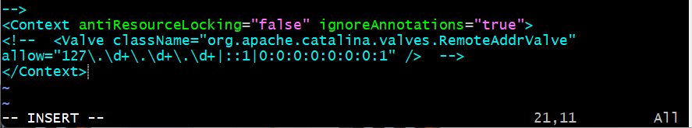

vi /opt/apache-tomcat-11.0.10/webapps/examples/META-INF/context.xml

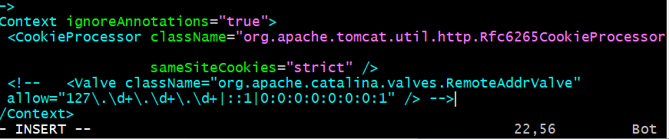

vi /opt/apache-tomcat-11.0.10/webapps/host-manager/META-INF/context.xml



vi /opt/apache-tomcat-11.0.10/webapps/manager/META-INF/context.xml



**Now go to conf in xml file add the below user details as shown in box.**

**cd /opt/** apache-tomcat-11.0.10/conf/

**vi tomcat-users.xml**

*<role rolename="manager-gui"/>*

*<role rolename="manager-script"/>*

*<role rolename="manager-jmx"/>*

*<role rolename="manager-status"/>*

*<user username="admin" password="admin" roles="manager-gui,manager-script,manager-jmx,manager-status"/>*

*<user username="deployer" password="deployer" roles="manager-script"/>*

*<user username="tomcat" password="s3cret" roles="manager-gui"/>*

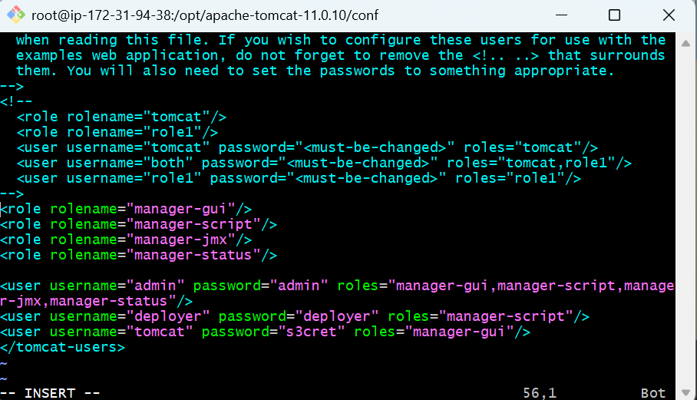

**After editing**

**Shutdown and start the tomcat**

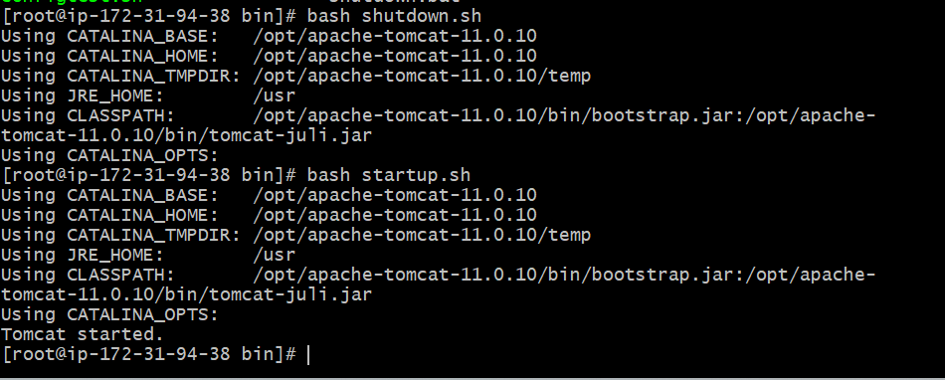

**Now in web page click on server status**

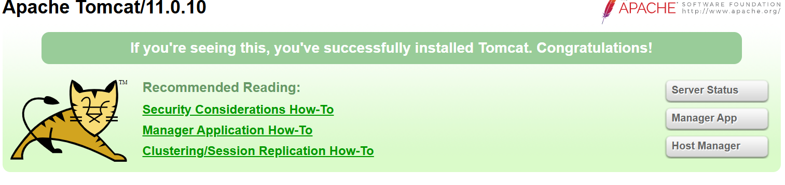

**Goto the tomcat page click on server status**

**Username – deployer**

**Password – deployer**

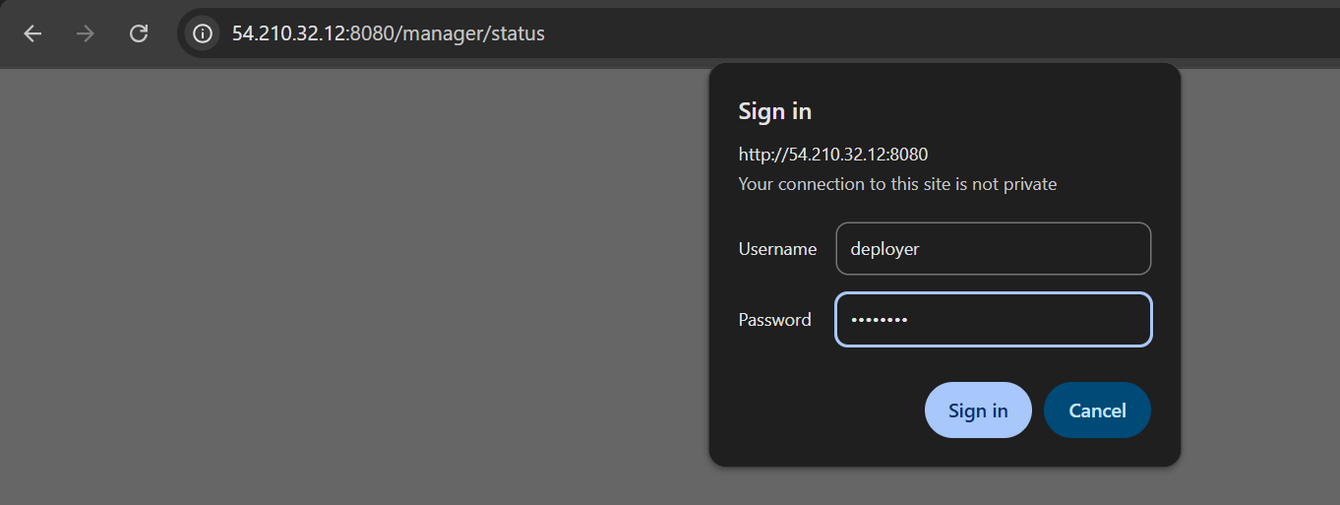

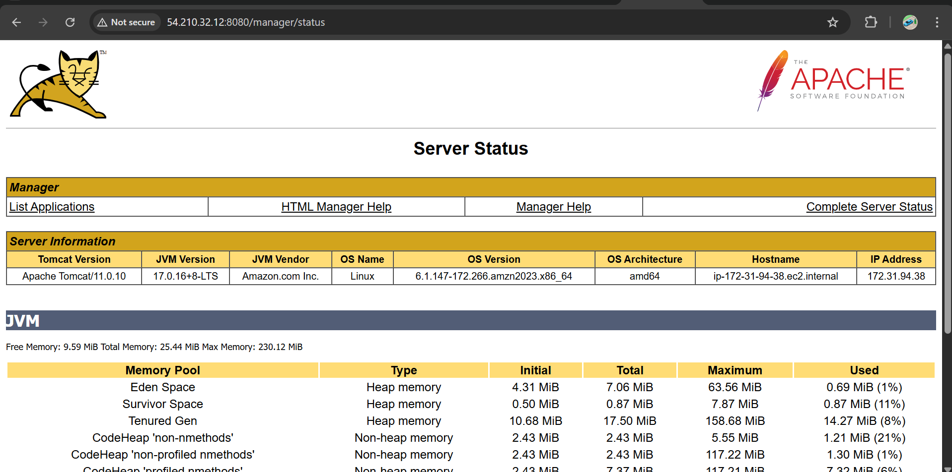

**Just go to jenkins add these credentials deployer and take WAR/EAR files as **/*.war**

**Add the same credentials**

**Username – deployer , Password – deployer**

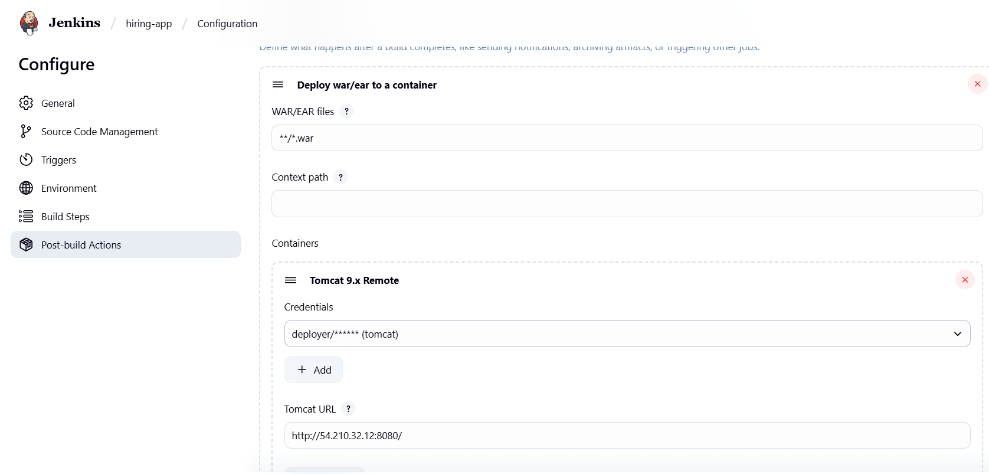

After save Run Build

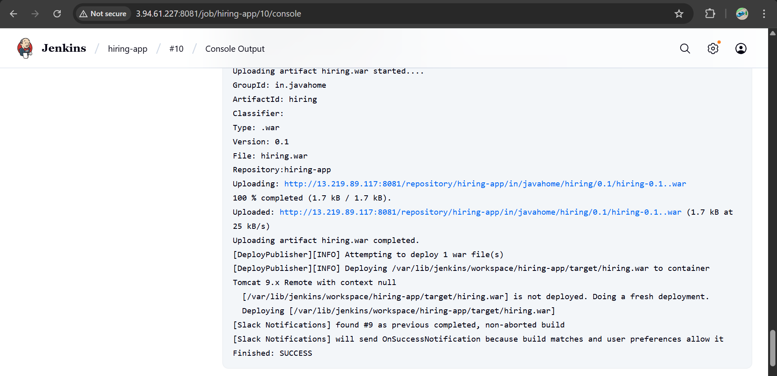

* **Now our deployment successfully done**
* Now you can check in tomcat cli webapps one file is shown
* Cd /opt/tomcat/webapps/hiring

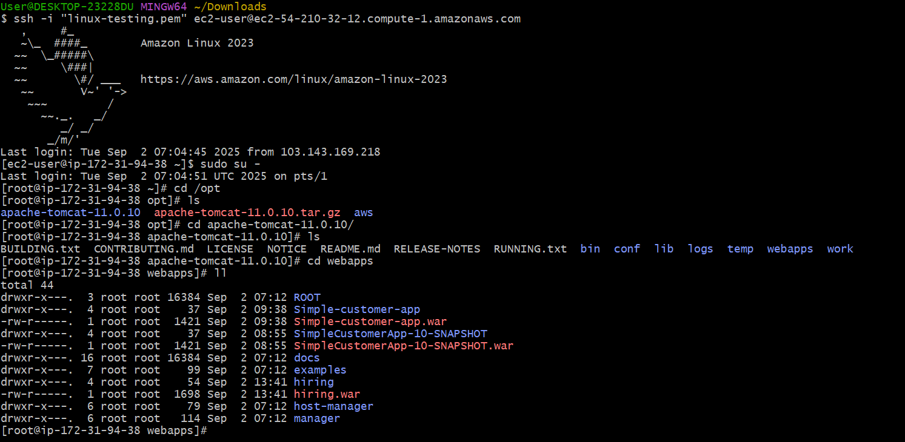

**And you can check in tomcat at browser we got our application is live.**

<http://54.210.32.12:8080/hiring/>

